Name-Harshad Hanamant Jagadale

PRN-2020BTEIT00025

DATABASE LAB

Batch T3

1.Select distinct

The SELECT DISTINCT statement is used to return only distinct (different) values.

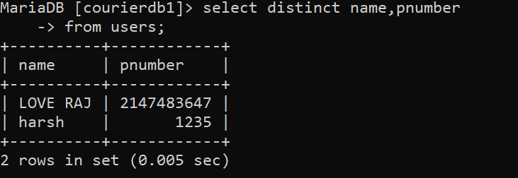

2.Select query:

The SELECT statement is used to select data from a database.

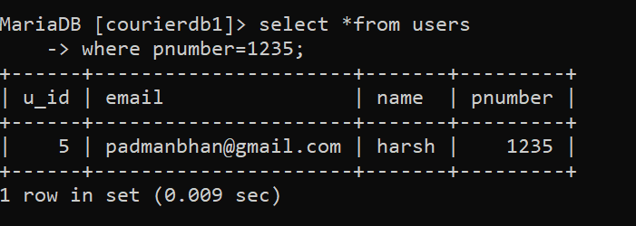

3.Where query

The WHERE clause is used to filter records.

.

4.Between query

The BETWEEN operator selects values within a given range. The values can be numbers, text, or dates.

4.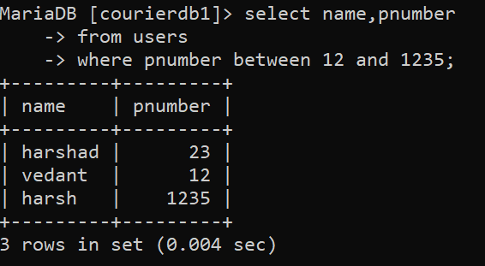

5.Nested query:

It consists of subqueries within query.

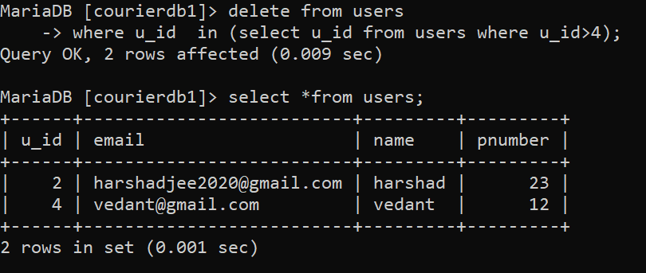

5.Group by

The GROUP BY statement is often used with aggregate functions (COUNT(), MAX(), MIN(), SUM(), AVG()) to group the result-set by one or more columns.

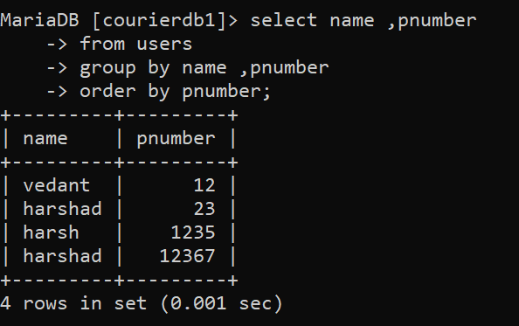

6.Having clause

The HAVING clause was added to SQL because the WHERE keyword cannot be used with aggregate functions.

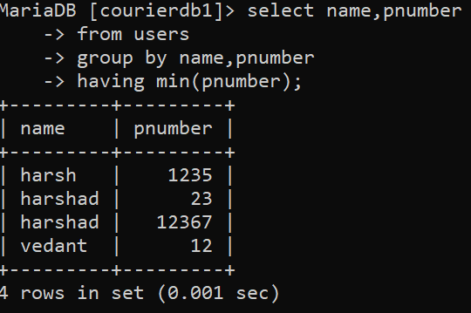

7.Update query:

The UPDATE statement is used to modify the existing records in a table.

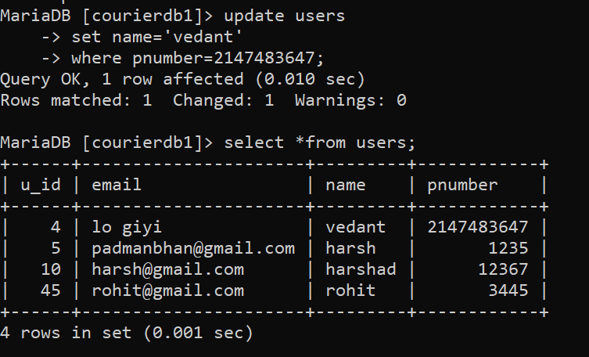

8.like

The LIKE operator is used in a WHERE clause to search for a specified pattern in a column.

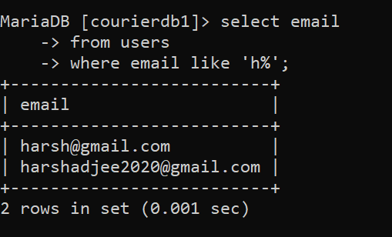

9.Select limit

The SELECT TOP clause is used to specify the number of records to return.

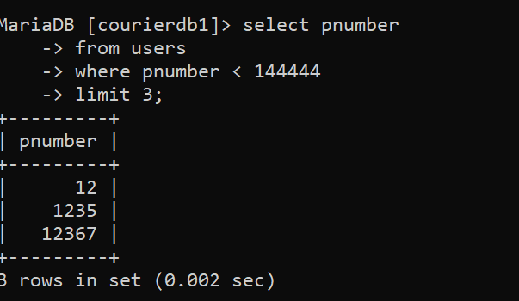

10.IN query:

The IN operator is a shorthand for multiple OR conditions.

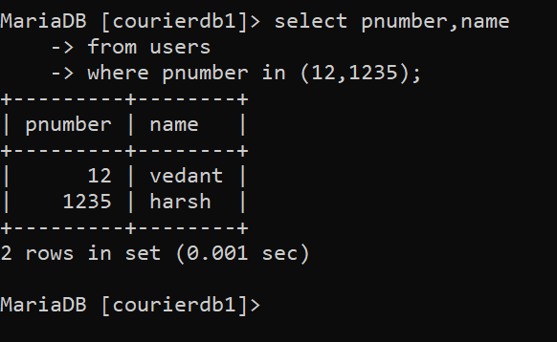

11.sum

The SUM() function returns the total sum of a numeric column.

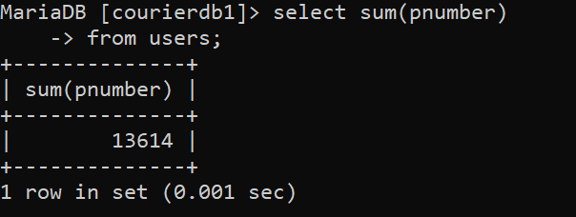

12.count

The COUNT() function returns the number of rows that matches a specified criterion.

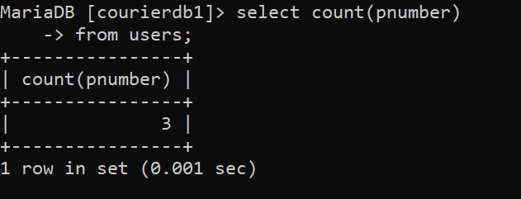

13.avg

The AVG() function returns the average value of a numeric column.

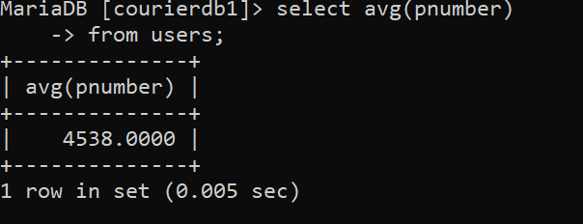

14.null

A field with a NULL value is a field with no value.

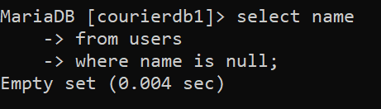

15.min

The MIN() function returns the smallest value of the selected column.

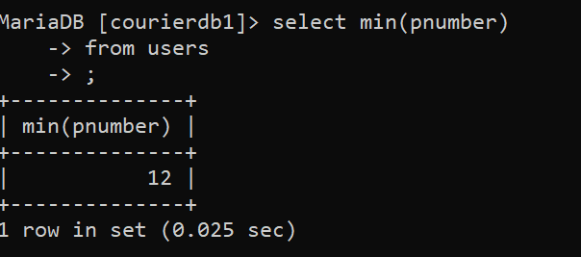

16.OR

The OR operator displays a record if any of the conditions separated by OR is TRUE.

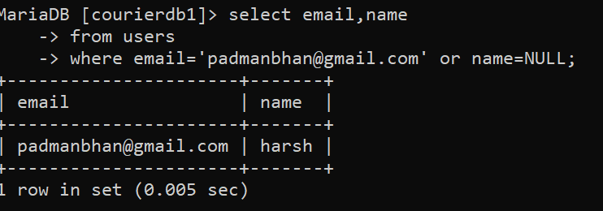

17.AND

* The AND operator displays a record if all the conditions separated by AND are TRUE.

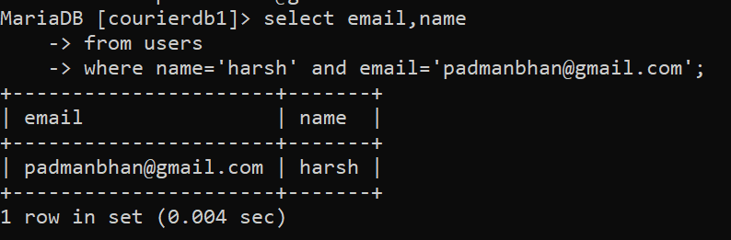

18.NOT

The NOT operator displays a record if the condition(s) is NOT TRUE.

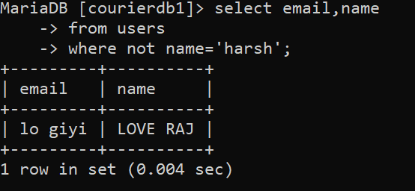

19.select limit

The SELECT TOP clause is used to specify the number of records to return.



20.Order by

The ORDER BY keyword is used to sort the result-set in ascending or descending order.

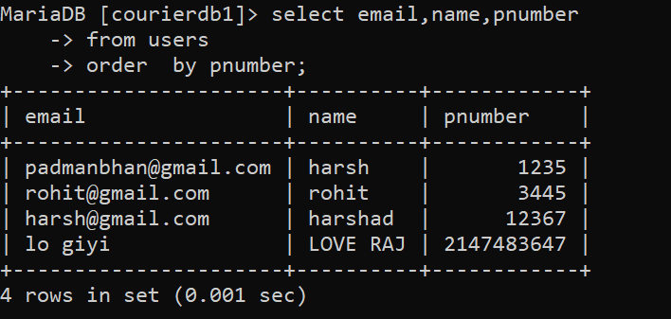

21.delete

The DELETE statement is used to delete existing records in a table.

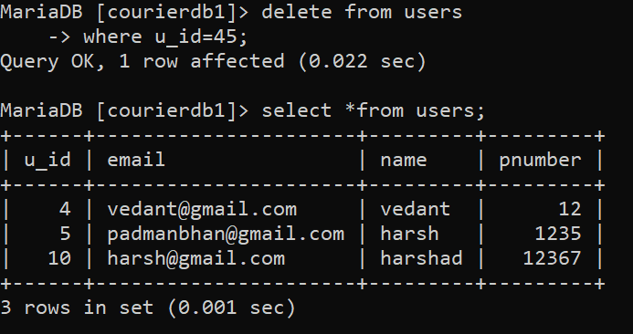

22.drop

The DROP DATABASE statement is used to drop an existing SQL database.

